Calculus Lifesaver PDF

Adrian Banner

Q&A

Questions

Contents

Chapter 1 – Functions, Graphs, Lines 1

Chapter 2 – Review of Trigonometry 9

Chapter 3 – Introduction to Limits 9

Chapter 4 – How To Solve Limit Problems Involving Polynomials 9

Chapter 5 – Continuity and Differentiability 10

Chapter 6 – How To Solve Differentiation Problems 10

Chapter 7 – Trig Limits and Derivatives 10

Chapter 8 – Implicit Differentiation and Related Rates 10

Chapter 9 – Exponentials and Logarithms 10

Chapter 10 – Inverse Functions and Inverse Trig Functions 10

Chapter 11 – The Derivative and Graphs 10

Chapter 12 – Sketching Graphs 11

Chapter 13 – Optimisation and Linearisation 11

Chapter 14 – L’Hopital’s Rule and Overview of Limits 11

# Chapter 1 – Functions, Graphs, Lines

1.1

What is a function?

1.2

What is the domain / co-domain?

1.3

What is R?

1.4

If function ‘g’ is similar to function ‘f’ but it operates on a smaller set of inputs (e.g. only non-negative numbers), what is this called?

1.5

How many outputs can a function create for each valid input?

1.6

What is the range of a function?

1.7

A common codomain is?

1.8

What does this mean? - 

1.9

What does this mean? - 

1.10

What is open vs closed interval.

1.11

What are these?

 and 

1.12

Interval notation for all numbers greater than or equal to a?

1.13

Interval notation for all numbers greater than a (but not equal to a) ?

1.14

What roots can you get for a negative number?

1.15

You can’t get the logarithm of what?

1.16

What’s problematic about tan(90degrees)?

1.17

If restrict the domain of a function, is it still the same function?

1.18

If change the domain, does the name of the function change?

1.19

What does this mean? 

1.20

How to check if a graph represents a function?

1.21

Does this represent a function?

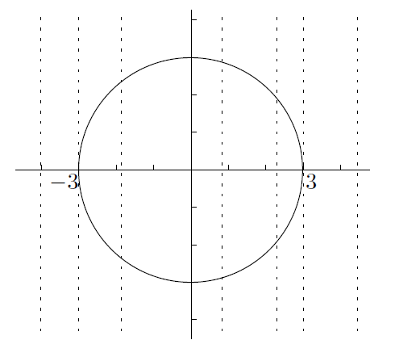

1.22

If the equation for a circle is x2 + y2 = 9, how to convert this into a function?

1.23

How to know if an inverse function exists.

1.24

How to use a graph to check if an inverse function exists

1.25

What does the inverse function look like on a graph?

1.26

What does this graph show?

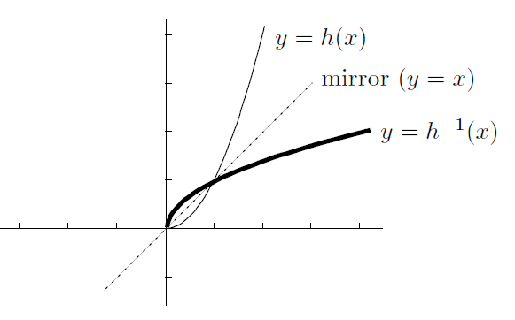

1.27

What’s the connection between the vertical and horizontal line tests?

1.28

What does this mean?



1.29

Is composition of functions the same as multiplication?

1.30

What does this mean? 

1.31

Is f(x) the composition of 2 functions?



1.32

How to sketch the function f(x) = (x-1)2

1.33

What is an “even” function?

1.34

What is an “odd” function?

1.35

Are most functions odd or even?

1.36

What is the only function that is both odd and even.

1.37

Why is knowing a function is ‘odd’ or ‘even’ interesting for plotting the graph

1.38

What is the product of 2 odd functions? Or the product of 2 even functions? Or the product of 1 even and 1 odd function?

1.39

What’s the form of a linear function.

1.40

How many points do you need to know, to sketch the graph of a linear function.

1.41

What’s the “point-slope form of a linear function”

1.42

If a line goes through (x1,y1) and (x2,y2), what is the slope?

1.43

What is a polynomial

1.44

What is the degree of a polynomial?

1.45

Are these odd or even? What does the plots look like?

Y=1 … y=x … y=x2 … y=x3 … y=x4 … y=x5 … y=x6 … y=x7

1.46

What is the leading coefficient?

1.47

How does the leading coefficient and the degree of the polynomial impact the edges of the graph i.e. the direction of the extreme values.

1.48

What’s a quadratic equation?

1.49

What is the discriminant and how is it written?

1.50

What are the 3 possibilities for the discriminant?

1.51

How to calculate the root of the discriminant?

1.52

What is a monic quadratic?

1.53

What is “completing the square” of a quadratic? And do it for the following quadratic:



1.54

What is a rational function?

1.55

What are the simplest examples of rational functions?

1.56

For functions of the following form 

Where ‘n’ is 1, 2, 3, 4. What do the graphs look like?

1.57

What does the graph of an exponential look like?

1.58

What does the graph of this look like:



1.59

What does the graph of this look like: 

1.60

What is the graph when the base is less than 1, e.g. 

1.62

What is the inverse function of 

1.63

What does the graph of  look like?

1.64

How to write the absolute value ?

1.65

What is 

1.66

Based on the foregoing, what is the region: 

1.67

How to get the graph of the absolute value of a function?

1.68

Draw the graph of 

1.69

Draw the graph of 

# Chapter 2 – Review of Trigonometry

2.1

# Chapter 3 – Introduction to Limits

# Chapter 4 – How To Solve Limit Problems Involving Polynomials

# Chapter 5 – Continuity and Differentiability

# Chapter 6 – How To Solve Differentiation Problems

# Chapter 7 – Trig Limits and Derivatives

# Chapter 8 – Implicit Differentiation and Related Rates

# Chapter 9 – Exponentials and Logarithms

# Chapter 10 – Inverse Functions and Inverse Trig Functions

# Chapter 11 – The Derivative and Graphs

# Chapter 12 – Sketching Graphs

# Chapter 13 – Optimisation and Linearisation

# Chapter 14 – L’Hopital’s Rule and Overview of Limits